Coordinate System Stem Lesson Ladder

PROGRESSION
Essential Foundational Knowledge (Roots) | - Construct a number line (choose origin, unit length, positive direction).  - Extend the number line to negatives.  - Absolute value as distance from 0 on the line.  - Counting lengths on a grid and relating counts to linear measure.  - Area on a grid (grounds axis-parallel rectangles later).  - Lines of symmetry 2D/reflections, right angles, opposite sides of a rectangle have equal length
Leads to | - Richer problem solving with the distance formula (HS).  - A separate Lines & Slope stem: slope via similar triangles; properties of linear functions; equation forms.  - 3-D extension of distance via PT (as an optional HS enrichment).
Big Ideas | - The coordinate plane is a plane with perpendicular axes (number lines) that intersect at 0.  - Each point in the plane has an ordered pair that describes its location in the coordinate plane... and every ordered pair corresponds to a unique point (bijection)  - We can find the distance between any 2 points in the coordinate plane.
Other Information | - Common misconception: Mixing up x and y coordinates  - X-coordinate describes horizontal distance from y-axis, y-coordinate describes the vertical distance from x-axis  - Keep units visible and identical on both axes.  - Require some hand plotting before tech; then transition to strategic tech use.  - See Wu’s algebra section 4.1 for delicate details

Concept/Skill: Construct Quadrant I of a coordinate system, plot points, and name ordered pairs.

Goal | - Construct a coordinate system in the plane.  - Plot points in the coordinate plane.  - Identify and write the ordered pair given a plotted point.
Student-Facing Example | 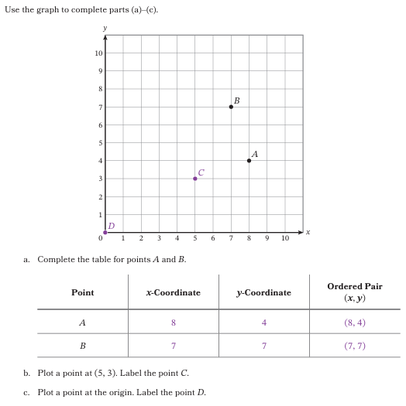
Knowledge Graph Node | Construct quadrant I of a coordinate system in the plane. | Write an ordered pair to describe the exact location of a point plotted in quadrant I of the coordinate plane. | Plot the exact location of a point in quadrant I of the coordinate plane. | Write an ordered pair to describe the approximate location of a point plotted in quadrant I of the coordinate plane. | Plot the approximate location of a point in quadrant I of the coordinate plane with scaled axes. | Solve problems involving Quadrant I of the coordinate plane.
Terminology | - Coordinate System: A coordinate system is a system that uses one or more numbers, or coordinates, to identify the location of a point.  - Coordinate Plane: A coordinate plane is a plane with a coordinate system used to describe locations of points in the plane. A coordinate plane has perpendicular axes that intersect at 0.  - Axes, x-axis, y-axis: Axes are the pair of perpendicular number lines that create a coordinate system. The x-axis is the horizontal number line in our conventional 2-dimensional coordinate system, 1 is traditionally placed to the right of 0. The y-axis is the vertical number line in our conventional 2-dimensional coordinate system, 1 is traditionally placed up from 0.  - Origin: The origin $O$ is the point where the x- and y-axes intersect. The origin has coordinates (0, 0).  - Coordinate: A coordinate is a number used to identify the location of a point. | - Coordinate, x-coordinate, y-coordinate: A coordinate is a number used to identify the location of a point. Each point $P$ has an ‘associated rectangle’ found by drawing lines through $P$ parallel to the x-axis and y-axis. The line through P parallel to the y-axis meets the x-axis at one point; the number at that point is the x-coordinate of P (likewise for y). These lines, together with the axes, form P's associated rectangle when P is off the axes.  - Ordered pair: An ordered pair is a pair of two numbers that describe the location of a point in the coordinate plane. An ordered pair is written (x, y), where x is the point’s x-coordinate and y is the point’s y-coordinate. | (none) | (none) | (none) | (none)
Mathematical Models | - Number line  - Coordinate plane | - Coordinate plane | - Coordinate plane | - Coordinate plane | - Coordinate plane | - Coordinate plane
Strategies | (none) | (none) | (none) | (none) | (none) | (none)
Specifications | - Start by plotting numbers on a number line  - What if the point is above a horizontal number line? Or to the right of a vertical number line? We can add another perpendicular number line to show how far away the point is.  - Once we have the coordinate plane set up, return to a point plotted on one of the number lines. How do we describe how far it is from this number line? It’s 0, so our ordered pair should have a 0 coordinate. | - Students will only write an ordered pair for points at the intersection of gridlines (ie, lattice points).  - Start with standard axes (ie, numbered 0-10 by 1s) and points with whole number coordinates  - Move to scaled axes that are multiples of whole numbers (ex: numbered 0-25, scaled by 5s; points have coordinates that are multiples of 5)  - Move to scaled axes that are fractions with denominators of 2 or 4 (unless a state or grade specifically calls for other denominators). (Ex: numbered 0-8, scaled by 1/2s; points have coordinates that are multiples of 1/2)  - As time allows or maybe an extension, include axes where not every gridline is labeled. Examples:  - Scaled by 1/4s but only the 1/2s are labeled; points have coordinates that are multiples of ¼  - Scaled by 1s but only the multiples of 3 are labeled; points have coordinates that are whole numbers  - Scaled by 5s by only the 10s are labeled; points have coordinates that are multiples of 5. | - (see previous node specifications)  - Students will only plot points at the intersection of gridlines (ie, lattice points)  - Require some hand plotting before tech; then transition to strategic tech use. | - Now students write ordered pairs for points not at the intersection of gridlines.  - Use language like “estimate” and “approximate” to drive home that we can’t be exact when it’s not on the gridlines. (Unless using tech for assistance.)  - Start with standard axes (ie, numbered 0-10, scaled by 1s) and points whose coordinates are multiples of ½.  - Move to scaled axes that are multiples of whole numbers (ex: numbered 0-20, scaled by 2s; points have coordinates that are whole numbers)  - Move to scaled axes that are fractions with denominators of 2 or 4 (unless a state or grade specifically calls for other denominators). (Ex: numbered 0-8, scaled by 1/2s; points have coordinates that are multiples of 1/4)  - Problem types will need to be reasonable (ie, don’t ask students to plot (1,3) on axes scaled 0-100 by 10s. That’s just rude.)  - We’ll need to “accept reasonable responses” rather than 1 exact, correct answer. | - (see previous node specifications)  - Now students plot points not at the intersection of gridlines.  - Use language like “estimate” and “approximate” to drive home that we can’t be exact when it’s not on the gridlines. (Unless using tech for assistance.)  - Require some hand plotting before tech; then transition to strategic tech use. | - Require some hand plotting before tech; then transition to strategic tech use.  - If possible, sprinkle this work throughout other lessons associated with this Concept, rather than saving it all for one big context lesson at the end.
Leaves to Include | (none) | (none) | (none) | (none) | (none) | (none)
Considerations | - First establish that the number line is a coordinate system they are familiar with that uses one number to identify the location of a point  - Define origin.  - Establish conventions: horizontal and vertical lines, equal length unit, perpendicular, cross at 0 (which is called the origin).  - Like the number line, the axes should have arrows that extend left and down from the origin. | - Possible Motivation: can we locate any point in the “plane” using only two numbers? Can use that Descartes and the Fly story idea here for funsies but don’t actually use that legend because probs not true. What about that battleship game?  - If we wanted to make a real world connection, could do so with maps. A1, B4, etc.  - The absolute value of the x-coordinate gives the perpendicular distance from the y-axis (the sign tells which side); likewise |y| for distance from the x-axis.  - Define equality for ordered pairs as having the same location, equivalently, (a, b) = (c, d) exactly when a = c and b = d, (ties location-equality to the bijection Big Idea) | (see previous node) | (see previous nodes) | (see previous nodes) | (see previous nodes)
Required Skills/Cases | - Quadrant I only  - Axes with 0, 1, 2, …,10 labeled | - Quadrant I only  - Given points on the x- or y-axis  - Given points not on the x- or y-axis  - Given a point at the origin  - Students should write the exact coordinates of points plotted at the intersection of gridlines.  - (see Specifications section for additional details) | - Quadrant I only  - Given ordered pairs where the x- or y-coordinate is 0  - Given ordered pairs where neither coordinate is 0  - Given (0,0)  - Students should write the exact coordinates of points plotted at the intersection of gridlines.  - (see Specifications section for additional details) | - Quadrant I only  - Given points on the x- or y-axis  - Given points not on the x- or y-axis  - Students should “estimate” the coordinates of points not at the intersection of gridlines (unless using technology).  - (see Specifications section for additional details) | - Quadrant I only  - Given ordered pairs where the x- or y-coordinate is 0  - Given ordered pairs where neither coordinate is 0  - Given (0,0)  - Students should “estimate” the location of points not at the intersection of gridlines (unless using technology).  - (see Specifications section for additional details) | - Quadrant I only  - Include choosing a scale for axes based on the data/points. (note that this becomes an extension if the previous nodes about scaled axes become leaves)  - Include both mathematical and real-world problems.  - Interpret coordinates in the context of a problem.  - This is a great place to do a little bit of data work!
Misconceptions | (none) | - mixing up x- and y- coordinates  - when counting from the origin to the point, counting the origin as 1 rather than 0 | - mixing up x- and y- coordinates  - when counting from the point to the origin, counting the point as 1 rather than 0 | - mixing up x- and y- coordinates | - mixing up x- and y- coordinates | - mixing up x- and y- coordinates
Existing Product Reference, if any | - EM2 G5 M6 TA L1  - EM2 G5 M6 TA L2 | - EM2 G5 M6 TA L2  - EM2 G5 M6 TA L3 | - EM2 G5 M6 TA L2  - EM2 G5 M6 TA L3 | - EM2 G5 M6 TA L3 | - EM2 G5 M6 TA L3 | - EM2 G5 M6 TB L5  - EM2 G5 M6 TB L6  - EM2 G5 M6 TB L7  - EM2 G5 M6 TC L11  - EM2 G5 M6 TC L12  - EM2 G5 M6 TC L13  - EM2 G5 M6 TC L14  - EM2 G5 M6 TC L15  - EM2 G5 M6 TD L16  - EM2 G5 M6 TD L17  - EM2 G5 M6 TD L18  - EM2 G5 M6 TD L19  - EM2 G5 M6 TD L20
Grade (or Leaf) | 5 | 5 | 5 | 5 | 5 | 5
Notes related to Standards, Grade, or Leaf | - CCSS.5.G.A.1  - FL.5.GR.4.1  - TX.5.8A | - CCSS.5.G.A.1  - CCSS.5.G.A.2  - FL.5.GR.4.2  - TX.5.8B  - TX.5.8C | - CCSS.5.G.A.1  - CCSS.5.G.A.2  - FL.5.GR.4.2  - TX.5.8B  - TX.5.8C | - CCSS.5.G.A.1  - CCSS.5.G.A.2  - FL.5.GR.4.2  - TX.5.8B  - TX.5.8C | - CCSS.5.G.A.1  - CCSS.5.G.A.2  - FL.5.GR.4.2  - TX.5.8B  - TX.5.8C | - CCSS.5.G.A.2  - FL.5.GR.4.2  - TX.5.8C
Notes for Intervention, Extension, or Optional Activities | Intervention:  - Number lines  - Points  - Lines  - Horizontal lines  - Vertical lines  - Perpendicular lines | Intervention:  - Identifying points plotted on a number line (scaled by whole numbers, multiples of whole numbers, and fractions) where the points are plotted at the intervals/tick marks | Intervention:  - Plotting points on a number line (scaled by whole numbers, multiples of whole numbers, and fractions) where the points are plotted at the intervals/tick marks | Intervention:  - Identifying points plotted on a number line (scaled by whole numbers, multiples of whole numbers, and fractions) where the points are plotted between the intervals/tick marks  - Identifying lattice points with whole number coordinates in Quadrant I of the coordinate plane. | Intervention:  - Plotting points on a number line (scaled by whole numbers, multiples of whole numbers, and fractions) where the points are plotted between the intervals/tick marks  - Plotting points with whole number coordinates in Quadrant I of the coordinate plane. | Intervention:  - Plotting points in the coordinate plane  - Writing ordered pairs given points in the coordinate plane
Additional Notes | 1 lesson | 1/2 lesson – combine with next node | 1/2 lesson – combine with previous node | 1/2 lesson - combine with next node | 1/2 lesson - combine with previous node | 1-2 lessons

Concept/Skill: Construct all four quadrants of a coordinate system, plot points, and name ordered pairs.

Goal | - Construct the coordinate plane and name the 4 quadrants of the coordinate plane.  - Plot points in all 4 quadrants of the coordinate plane.  - Identify and write the ordered pair given a plotted point.  - Identify the quadrant of a point given only the signs of the coordinates, and the signs of the coordinates given the quadrant of a point.
Student-Facing Example | 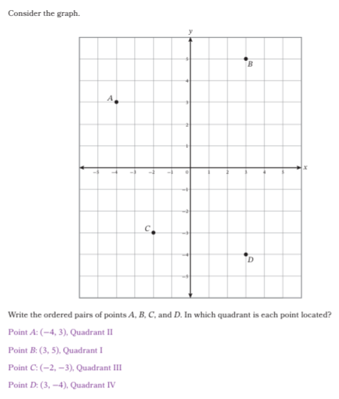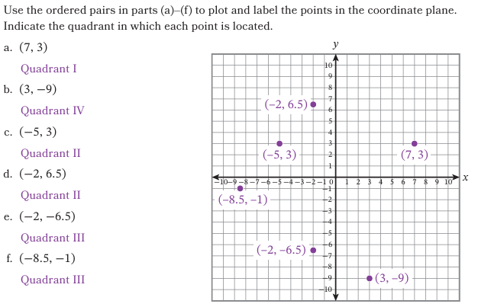
Knowledge Graph Node | Construct and name the 4 quadrants of the coordinate plane. | Write an ordered pair to describe the location of a point with integer coordinates plotted in any quadrant of the coordinate plane. | Plot points with integer coordinates in any quadrant of the coordinate plane. | Determine the signs of the $x$- and $y$-coordinates of a point in a given quadrant. | Determine a point’s quadrant by using the signs of the $x$- and $y$-coordinates. | Write an ordered pair to describe the location of a point with rational coordinates plotted in any quadrant of the coordinate plane with scaled axes. | Plot points with rational coordinates in any quadrant of the coordinate plane with scaled axes.
Terminology | - Quadrant: One of the four regions in the coordinate plane formed by the intersection of the x- and y-axes. | (none) | (none) | (none) | (none) | (none) | (none)
Mathematical Models | - Coordinate plane  - Integer number line | - Coordinate plane | - Coordinate plane | - Coordinate plane | - Coordinate plane | - Coordinate plane  - Rational number line  - Scaled number line | - Coordinate plane  - Rational number line  - Scaled number line
Strategies | - Identify quadrants by starting in upper right and moving counterclockwise | (none) | (none) | (none) | (none) | (none) | (none)
Specifications | - Axes scaled from -10 to 10 with consecutive integers labeled | - Start with points that have non-zero coordinates (not on the axes)  - Address points on the axes once proficient with points not on the axes  - Axes with consecutive integers labeled  - Integer coordinates only | - Start with points that have non-zero coordinates (not on the axes)  - Address points on the axes once proficient with points not on the axes  - Axes with consecutive integers labeled  - Integer coordinates only | - Start with concrete examples of points shown in each quadrant  - Move toward abstraction by noticing patterns and removing the coordinate plane  - Include points with coordinates not readily identifiable on a standard -10 to 10 coordinate plane | - Start with concrete examples of points shown in each quadrant  - Move toward abstraction by noticing patterns and removing the coordinate plane  - Include points with coordinates not readily identifiable on a normal -10 to 10 coordinate plane | - Consider including grid lines to help with identifying ordered pairs of points with fraction/decimal coordinates  - Positive and negative rational number coordinates | - Consider including grid lines to help plotting points with fraction/decimal coordinates  - Positive and negative rational number coordinates
Leaves to Include | (none) | (none) | (none) | (none) | (none) | (none) | (none)
Considerations | - Choose origin and positive directions.  - Establish conventions: horizontal and vertical lines, left and down are negative, equal length unit, perpendicular, cross at 0 (which is called the origin). | - Use rectangles as support to plot points.  - Include scaled axes.  - Represent real-world and mathematical problems in all 4 quadrants.  - X-coordinate gives perpendicular distance from the y-axis. Y-coordinate gives perpendicular distance from x-axis.  - Common mistake: mixing up x- and y- coordinates. | - Define equality for ordered pairs. (That is, two ordered pairs that plot the same point are equal. Connect to number line. Ex: (1/2, 2) plots the same point as (0.5,2) and (1/2, 4/2), so all of those ordered pairs are equal.  - Given a point, name the point(s) whose ordered pair differs only by sign(s), and describe the two locations as reflections across the x-axis, y-axis, or both. | (see previous nodes) | (see previous nodes) | - Include rational number coordinates. | (see previous nodes)
Required Skills/Cases | (none) | - Points on the x- or y-axis  - Points not on the x- or y-axis  - Point at the origin  - Axes with consecutive integers labeled  - Integer coordinates only  - Given a point, name the point(s) whose ordered pair differs only by sign(s), and describe the two locations as reflections across the x-axis, y-axis, or both. | - Ordered pairs with a 0 x- or y-coordinate  - Ordered pairs with no 0 coordinate  - (0,0) ordered pair  - Axes with consecutive integers labeled  - Integer coordinates only | - Points shown in the coordinate plane  - Ordered pairs given without the coordinate plane shown | - Points within a standard -10 to 10 coordinate plane  - Points outside a standard -10 to 10 coordinate plane | - Scales that are multiples of integers  - Scales that are rational numbers  - Write the exact ordered pair given a point at the intersection of two gridlines  - Estimate the ordered pair given a point not at the intersection of two gridlines  - Points on the x- or y-axis  - Points not on the x- or y-axis  - Point at the origin | - Scales that are multiples of integers  - Scales that are rational numbers  - Plot the exact location of a point at the intersection of two gridlines  - Estimate the location of a point not at the intersection of two gridlines  - Ordered pairs with a 0 x- or y-coordinate  - Ordered pairs with no 0 coordinate  - (0,0) ordered pair
Misconceptions | - Mixing up left/down is negative and right/up is positive  - Mixing up vertical axis is y and horizontal axis is x | - mixing up x- and y- coordinates | - mixing up x- and y- coordinates | - mixing up x- and y- coordinates | - mixing up x- and y- coordinates | - mixing up x- and y- coordinates  - for a rational number, misidentifying the whole number. Ex: if a point is between 2 and 3, is it 2.5 or 1.5? If a point is between -1 and -2, is it -1.5 or -2.5? | - mixing up x- and y- coordinates  - for a rational number, misidentifying the location relative to the whole number. Ex: If the coordinate is 1.5, is that to the left or right of 1? If the coordinate is -3.5, is that to the left or right of 3?
Existing Product Reference, if any | - EM2 G6 M3 TC L10 | - EM2 G6 M3 TC L10 | - EM2 G6 M3 TC L11 | - EM2 G6 M3 TC L10-11 | - EM2 G6 M3 TC L10-11 | - EM2 G6 M3 TC L10 | - EM2 G6 M3 TC L11
Grade (or Leaf) | 6 | 6 | 6 | 6 | 6 | 6 | 6
Notes related to Standards, Grade, or Leaf | - 6.NS.C.6  - 6.NS.C.6.b  - FL.6.GR.1.1  - TX.6.11  - VA.6.MG.3.a | - CCSS.6.NS.C.6  - CCSS.6.NS.C.6.c  - FL.6.GR.1.1  - TX.6.11  - VA.6.MG.3.d*  - VA.6.MG.3.e*  * Ordered pairs will be limited to coordinates expressed as integers. | - CCSS.6.NS.C.6  - CCSS.6.NS.C.6.c  - CCSS.6.NS.C.8  - FL.6.GR.1.1  - TX.6.11  - VA.6.MG.3.c*  - VA.6.MG.3.e*  * Ordered pairs will be limited to coordinates expressed as integers. | - CCSS.6.NS.C.6.b  - FL.6.GR.1.1  - TX.6.11  - VA.6.MG.3.b*  * Ordered pairs will be limited to coordinates expressed as integers. | - CCSS.6.NS.C.6.b  - FL.6.GR.1.1  - TX.6.11  - VA.6.MG.3.b*  * Ordered pairs will be limited to coordinates expressed as integers. | - CCSS.6.NS.C.6.b  - CCSS.6.NS.C.6.c  - FL.6.GR.1.1  - TX.6.11* | - CCSS.6.NS.C.6.b  - CCSS.6.NS.C.6.c  - FL.6.GR.1.1  - TX.6.11*
Notes for Intervention, Extension, or Optional Activities | Intervention:  - Roman numerals  - Clockwise/counterclockwise  - Number lines with negative integers  - Number lines with positive and negative rational numbers  - Horizontal number lines  - Vertical number lines  - Opposites of integers | In-lesson supports:  - Describe location of point in words (ex: the point (2,3) is right 2 units and up 3 units)  Intervention:  - Identifying points on a number line with negative integers  - Identifying points on a number line with positive and negative rational numbers  - Identifying points in Quadrant I (including whole numbers and rational numbers) | In-lesson supports:  - Describe location of point in words (ex: the point (2,3) is right 2 units and up 3 units)  Extension:  - Discuss why we can’t order ordered pairs. Make explicit comparison to the number line (where we can order numbers). We might not be able to order them like we can rational numbers, but we can tell how far apart they are from each other.  Intervention:  - Plotting points on a number line with negative integers  - Plotting points on a number line with positive and negative rational numbers  - Plotting points in Quadrant I (including whole numbers and rational numbers) | In-lesson supports:  - Create a graphic organizer to help students summarize  Intervention:  - Identifying points in all four quadrants (include positive and negative integers and rational numbers) | Intervention:  - Plotting points in all four quadrants (include positive and negative integers and rational numbers)  - Identifying points in all four quadrants (include positive and negative integers and rational numbers) | In-lesson supports:  - Describe location of point in words (ex: the point (2.5,-3.5) is right 2.5 units and down 3.5 units)  Intervention:  - Identifying points on a number line with positive and negative rational numbers  - Identifying points in all 4 quadrants with integer coordinates  - Identifying points on a scaled number line  - Identifying points with whole number coordinates in Quadrant I of the coordinate plane.  - Identifying points in Quadrant I of the coordinate plane with scaled axes.  - Identify points in all four quadrants of the coordinate plane with axes scaled with consecutive integers | In-lesson supports:  - Describe location of point in words (ex: the point (2.5,-3.5) is right 2.5 units and down 3.5 units)  Extension:  - Discuss why we can’t order ordered pairs. Make explicit comparison to the number line (where we can order numbers). We might not be able to order them like we can rational numbers, but we can tell how far apart they are from each other.  Intervention:  - Plotting points on a number line with positive and negative rational numbers  - Plotting points in all 4 quadrants with integer coordinates  - Plotting points on a scaled number line  - Plotting points with whole number coordinates in Quadrant I of the coordinate plane.
Additional Notes | 1 lesson | 1/2 lesson – combine with next node | 1/2 lesson – combine with previous node | 1/2 lesson – combine with next node | 1/2 lesson – combine with previous node | 1/2 lesson – combine with next node | 1/2 lesson – combine with previous node

Knowledge Graph Node | Solve problems involving all 4 quadrants of the coordinate plane.
Terminology | (none)
Mathematical Models | - Coordinate plane
Strategies | (none)
Specifications | - Include choosing a scale for the coordinate plane based on the data/points.  - Include both mathematical and real-world problems.  - Interpret coordinates in the context of a problem.
Leaves to Include | (none)
Considerations | (see previous nodes)
Required Skills/Cases | (none)
Misconceptions | - mixing up x- and y- coordinates
Existing Product Reference, if any | - EM2 G6 M3 TC L13  - EM2 G6 M3 TC L14
Grade (or Leaf) | 6
Notes related to Standards, Grade, or Leaf | - CCSS.6.NS.C.8  - FL.6.GR.1.3  - TX.6.11*  *only calls for plotting, there are no G6 TX standards regarding problem-solving in the coordinate plane until G8 using Pythagorean Theorem
Notes for Intervention, Extension, or Optional Activities | Optional activities:  - Finding/plotting coordinates of stars in constellations  Intervention:  - Plotting and identifying points in all 4 quadrants
Additional Notes | 1-2 lessons

Concept/Skill: Find the distance between 2 points with same x- or same y-coordinate.

Goal | - Find the distance between two points that are both on a vertical line (also horizontal).  - Form a conjecture about a general method/formula for above.  - Understand proof that for any 2 points on a horizontal line, the distance between them is given by |x₂ − x₁|. On a vertical line: distance is |y₂ − y₁|. Observe that the coordinate chosen for x₁, x₂ and y₁, y₂ doesn't matter.
Student-Facing Example | 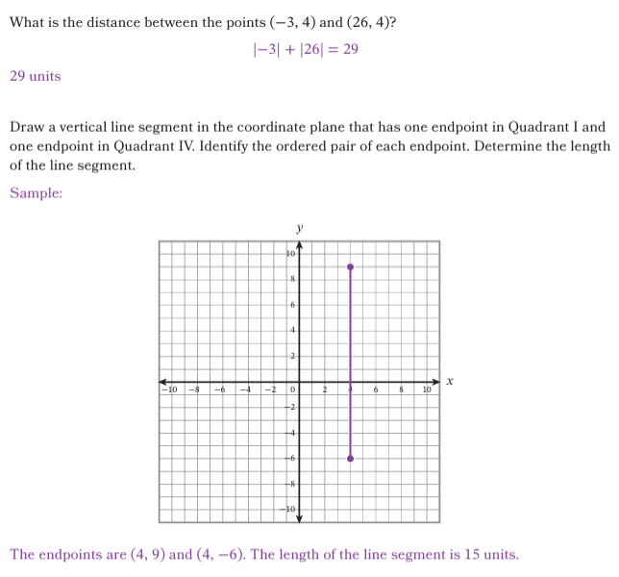  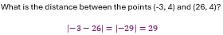
Knowledge Graph Node | Find the distance between two points that lie on a vertical or horizontal line by counting units (unit intervals). | Use the difference of the absolute values of the coordinates (|x₂| − |x₁| or |y₂| − |y₁|, greater minus lesser) to calculate the distance between 2 points in the same quadrant with the same x- or y-coordinate. | Use |x₁| + |x₂| or |y₁| + |y₂|to calculate the distance between 2 points in different quadrants with the same x- or y-coordinate. | Solve problems involving the distance between two points with the same x- or y-coordinate. | Summarize a proof that the distance between any 2 points on a horizontal line is |x₂ − x₁| and the distance between any 2 points on a vertical line is |y₂ − y₁|. | Use |x₂ − x₁| or |y₂ − y₁| to calculate the distance between any 2 points with the same x- or same y-coordinate. | Plot the reflection of a point about the x- or y-axis.
Terminology | (none) | (none) | (none) | (none) | (none) | (none) | (none)
Mathematical Models | - Coordinate plane | - Coordinate plane | - Coordinate plane | - Coordinate plane | - Coordinate plane | - Coordinate plane | - Coordinate plane
Strategies | (none) | - Find a pattern and form a conjecture. | - Find a pattern and form a conjecture. | (none) | - Find a pattern, form a conjecture, show that it’s always true. | (none) | - Find a pattern and form a conjecture.
Specifications | - Technically, this can/should only be done with integer coordinates.  - Consider using rational coordinates as motivation to move to the next node.  - Only use integers for VA standard | - Include finding a point’s distance from an axis to conceptually prep for adding absolute values in the next node | - Start with integer coordinates and move to rational coordinates | - Include solving geometric, mathematical, and real-world problems.  - Must include finding perimeter and area of a rectangle in the coordinate plane for FL | - Start by giving the coordinates of 2 points that lie on a horizontal or vertical line, show that the distance between those 2 points is |x₂ − x₁| on a horizontal line and is |y₂ − y₁| on a vertical line.  - Consider only using integers for instruction and introducing rational numbers during practice  - Possible motivation: We have 2 different methods for finding distance depending on whether the points are in the same or different quadrants. I wonder if there’s one method that works for both cases.  - See this document for notes on the proof: Notes on Distance Between Two Points Proof.docx  - The thoroughness and student ownership of the proof (i.e. does the teacher lead them through it? Do they help complete parts? Etc) will depend entirely on the grade level. If we do it in G7 after they learn to operate with rational numbers, there should be a lot more scaffolding and direction from the teacher. If we do it in HS alongside distance formula, there should be a lot more student ownership.  - Observe that the coordinate chosen for x1 vs. x2 and y1 vs. y2 doesn't matter | - Start with integers and move to rational numbers  - Include solving problems: geometric, real-world, and mathematical contexts. | - Start with integer coordinates, move to “easy” rational coordinates like halves  - Counting unit intervals to determine distance from a point to an axis.  - Start by observing reflections, then plotting reflected points.  - Reflections over a single axis  - Just reflect points for this leaf. Reflect whole figures/images in the next leaf.
Leaves to Include | (none) | (none) | (none) | (none) | (none) | (none) | (none)
Considerations | - All 4 quadrants, and cross axes. | - Motivation: How far apart are these two points? What if counting the squares is too hard?  - Don’t be afraid of using rational numbers. | - Can do this across quadrants before learning how to add/subtract rational numbers by leveraging absolute value and distance to an axis. | (see previous nodes) | - Must know subtraction of rational numbers. | (see previous nodes) | (see previous nodes)
Required Skills/Cases | Sprinkle cases where one or more coordinates are 0 | Sprinkle cases where one or more coordinates are 0 | Sprinkle cases where one or more coordinates are 0 | among many many different problem types, make sure to cover CCSS.6.G.A.3 adequately here:  Draw a polygon given the coordinates of its vertices; find side lengths joining points with the same first or second coordinate; perimeter/area of axis-parallel rectangles  Sprinkle cases where one or more coordinates are 0 | (none) | Sprinkle cases where one or more coordinates are 0 | Sprinkle cases where one or more coordinates are 0
Misconceptions | - Counting the starting gridline as 1 instead of 0 | - Using the difference of the coordinates, not the difference of their absolute values  - getting negative distances | - Using the sum of the coordinates, not the sum of their absolute values  - Using the difference of the coordinates  - Getting negative distances | - Incorrectly finding distance between two points  - Difficulty decontextualizing to calculate and recontextualizing to solve | - Pattern/conjecture does not equal proof | - Difficulty decontextualizing to calculate and recontextualizing to solve | - mixing up x- and y- coordinates  - reflected points are not equidistant from the axes  - difficulty maintaining the distance between two points after applying a reflection (ex: points A and B are 3 units apart. A’ and B’ are the images of A and B after a reflection. But, an error is made so that A’ and B’ are 4 units apart)
Existing Product Reference, if any | - EM2 G6 M3 TD L15 | - EM2 G6 M3 TD L15 | - EM2 G6 M3 TD L15  - EM2 G6 M3 TD L17 | - EM2 G6 M3 TD L15  - EM2 G6 M3 TD L16  - EM2 G6 M3 TD L17 | (none) | (none) | - EM2 G6 M3 TC L12  EM2 G6 M3 TD L16
Grade (or Leaf) | 6 | 6 | 6 | 6 | Any time after these skills are introduced:  - Integer operations  - Distance between two points with the same x- or y-coordinate | Any time after these skills are introduced:  - Integer operations  - Distance between two points with the same x- or y-coordinate | Leaf (state-specific*)  * Necessary to address FL.6.GR.1.1
Notes related to Standards, Grade, or Leaf | - CCSS.6.NS.C.6.c  - CCSS.6.NS.C.8  - CCSS.6.G.A.3  - FL.6.GR.1.1  - FL.6.GR.1.2  - TX.6.11*  - NE.7.G.2.b  - SC.7.MGSR.3.1  - VA.6.MG.3.e  *only calls for plotting, there are no TX standards regarding distance between points until G8 using Pythagorean Theorem | - CCSS.6.NS.C.6.c  - CCSS.6.NS.C.8  - CCSS.6.G.A.3  - FL.6.GR.1.1  - FL.6.GR.1.2  - TX.6.11*  - NE.7.G.2.b  - SC.7.MGSR.3.1  *only calls for plotting, there are no TX standards regarding distance between points until G8 using Pythagorean Theorem | - CCSS.6.NS.C.6.c  - CCSS.6.NS.C.8  - CCSS.6.G.A.3  - FL.6.GR.1.1  - FL.6.GR.1.2  - TX.6.11*  - NE.7.G.2.b  - SC.7.MGSR.3.1  *only calls for plotting, there are no TX standards regarding distance between points until G8 using Pythagorean Theorem | - CCSS.6.G.A.3  - FL.6.GR.1.3  - TX.6.11*  - NE.7.G.2.b  *only calls for plotting, there are no TX standards regarding distance between points until G8 using Pythagorean Theorem | - Not explicitly called out anywhere. Students need to be able to operate with integers for this concept. But they do need this concept to help them derive the distance formula. | - Not explicitly called out anywhere. Students need to be able to operate with integers for this concept. But they do need this concept to help them derive the distance formula. | - CCSS.6.NS.C.6.b  - CCSS.6.NS.C.8  - FL.6.GR.1.1
Notes for Intervention, Extension, or Optional Activities | Extension:  - Coordinate planes with scaled axes  Intervention:  - Plotting and identifying points in all 4 quadrants | Extension:  - Given a point, find the coordinates of another point that is Z units away (within one quadrant)  Intervention:  - Opposites of numbers  - Absolute value | Extension:  - Given a point, find the coordinates of another point that is Z units away (across two quadrants)  Intervention:  - Opposites of numbers  - Absolute value | Intervention:  - Properties/classifications of polygons | Intervention:  - Absolute value is distance from 0  - Subtraction with integers/rational numbers  - Find the distance between two points that are both on a vertical or horizontal line by counting unit intervals.  - Find the distance between 2 points with same x- or same y-coordinate in the same quadrant by using the difference of the absolute values of the coordinates.  - Find the distance between 2 points with same x- or same y-coordinate in different quadrants by using the sum of the absolute values of the coordinates.  Extension: If students know exponents and square roots, extend by showing: $\left|x_{2}- x_{1}\right|=\sqrt{{\left(x_{2}- x_{1}\right)}^{2}}$  - Find a pattern and form a conjecture, prove conjecture  - Depending on grade level, may want to verify experimentally or show an informal proof.  - This is a great extension/bridge if this concept/skill is not included in the same grade level as the distance formula. | Intervention:  - Absolute value  - Subtraction with integers/rational numbers  - Find the distance between 2 points with same x- or same y-coordinate by finding the absolute value of the difference between coordinates. | Extension:  - Apply 2 reflections (one over each axis)
Additional Notes | 1/2 to 1 lesson:  - 1 lesson if we include scaled axes  - 1/2 lesson if we just cover counting unit intervals  - Could also combine with other two nodes:  - 1 lesson to count gridlines and find the formula within one quadrant  - 1 lesson to count gridlines and find the formula across two quadrants | 1 lesson (see previous node Additional Notes) | 1 lesson (see previous node Additional Notes) | 1-2 lessons | 1 lesson | 1 lesson | 1/2 to 1 lesson – could be combined with “Fun with symmetries.”

Knowledge Graph Node | Draw a line of symmetry for a figure in the coordinate plane.
Terminology | (none)
Mathematical Models | - Coordinate plane
Strategies | - (none)
Specifications | - Start with familiar figures like symmetric letters  - Connect to reflection
Leaves to Include | (none)
Considerations | (see previous nodes)
Required Skills/Cases | (none)
Misconceptions | - not preserving distances between points  - difficulty creating symmetric images without points plotted
Existing Product Reference, if any | - EM2 G5 M6 TC L12  - EM2 G6 M3 TD L16
Grade (or Leaf) | Leaf (flexible)
Notes related to Standards, Grade, or Leaf | - CCSS.6.NS.C.6.b  - CCSS.6.NS.C.8
Notes for Intervention, Extension, or Optional Activities | (none)
Additional Notes | 1/2 to 1 lesson – could be combined with “Reflection of points about the x- or y-axis.”

Concept/Skill: Find the distance between any 2 points by using the Pythagorean theorem.

Goal | - Use the Pythagorean Theorem to find the distance between 2 points: For $A(a,b)$, $C(c,d)$, build the triangle with legs $∥a-c∥$and $∥b-d∥$; $AC=\sqrt{(a-c)^{2}+(b-d)^{2}}$.
Student-Facing Example | 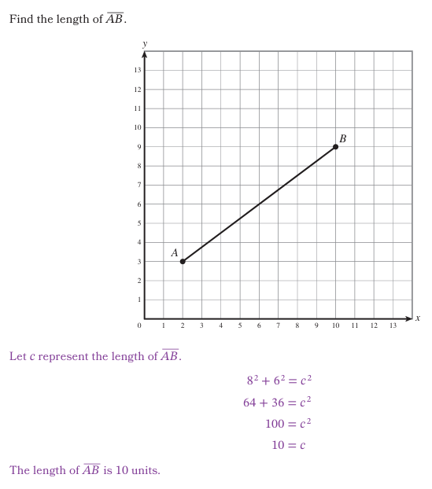
Knowledge Graph Node | Use the Pythagorean Theorem to find the distance between two points in the coordinate plane that do not lie on a horizontal or vertical line. | Solve problems by using the Pythagorean Theorem to find the distance between two points in the coordinate plane.
Terminology | (none) | (none)
Mathematical Models | - Coordinate plane | - Coordinate plane
Strategies | (none) | (none)
Specifications | - Students are counting unit intervalsre to determine the lengths of the legs.  - First, have students use the Pythagorean Theorem to find the length of the hypotenuse of a right triangle in the coordinate plane  - Then, have them use the Pythagorean Theorem to find the length of a non-horizontal and non-vertical line segment in the coordinate plane (remove the legs of the triangle)  - Then have them find the distance between two points (remove the hypotenuse segment and just show the points) | - Include geometric, real world, and mathematical contexts
Leaves to Include | (none) | (none)
Considerations | - Motivation: How far apart are these two points? Why can’t I just “count boxes” diagonally? | (none)
Required Skills/Cases | - Start with side lengths that are Pythagorean Triples  - Leg lengths should be whole numbers  - Coordinates of hypotenuse endpoints should be integers  - Where applicable, express answers in exact form not decimal approximations (ex: $AB=\sqrt{10}$)  - Include triangles in different orientations, but legs should always be vertical and horizontal line segments | (none)
Misconceptions | - Mixing up legs and hypotenuses  - Thinking a distance can be negative (e.g., reporting a negative leg length) | - Difficulty decontextualizing to calculate and recontextualizing to solve
Existing Product Reference, if any | - G8 M2 TD L20 | - G8 M2 TD L20 Classwork 5
Grade (or Leaf) | 8 | 8
Notes related to Standards, Grade, or Leaf | - CCSS.8.G.B.8  - FL.8.GR.1.2  - TX.8.7D | - CCSS.8.G.B.8  - FL.8.GR.1.2  - TX.8.7D
Notes for Intervention, Extension, or Optional Activities | Intervention:  - Using Pythagorean Theorem to find the length of the hypotenuse of a right triangle  - Identifying the legs and hypotenuse of a right triangle  - Squares  - Square roots | Intervention:  - Using Pythagorean Theorem to find the length of the hypotenuse of a right triangle  - Identifying the legs and hypotenuse of a right triangle  - Squares  - Square roots
Additional Notes | 1/2 to 1 lesson (could be possibly combined with next node) | 1/2 to 1 lesson (could be possibly combined with previous node)

Concept/Skill: Find the distance between any 2 points by using the distance formula.

Goal | - Derive and use the distance formula: $\sqrt{(x_{2}-x_{1})^{2}+(y_{2}-y_{1})^{2}}$. Observe that the coordinate chosen for x₁, x₂ and y₁, y₂ doesn't matter.
Student-Facing Example | 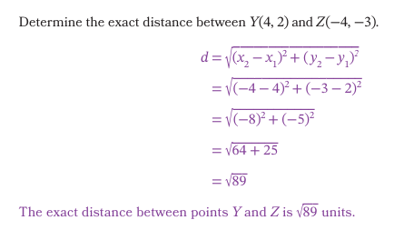
Knowledge Graph Node | Use the Pythagorean theorem to derive the distance formula: $\sqrt{(x_{2}-x_{1})^{2}+(y_{2}-y_{1})^{2}}$. | Use the distance formula to determine the distance between any two points in the coordinate plane. | Solve problems by using the distance formula.
Terminology | (none) | (none) | (none)
Mathematical Models | (none) | (none) | (none)
Strategies | (none) | (none) | (none)
Specifications | - Possible motivation: What if I want to find distance, but I don’t want to count squares in the coordinate plane? (i.e. don’t have the image in the coordinate plane or the points are too far apart to count gridlines)  - Use the Pythagorean Theorem to derive the formula $c=\sqrt{a^{2}+b^{2}}$ to find the distance between two points that do not lie on a horizontal or vertical line in the coordinate plane. connect that a = |x₁ − x₂| and b = |y₁ − y₂|, and substitute. Since |x₁ − x₂|² = (x₁ − x₂)², the absolute value bars drop once squared — which is why the formula needs none.. | - Start with integer coordinates that result in integer values for $x_{1}-x_{2}$ and $y_{1}-y_{2}$. Move to non-integer coordinates and values for $x_{1}-x_{2}$ and $y_{1}-y_{2}$ as appropriate. | - Include mathematical, geometric, and real world contexts.
Leaves to Include | (none) | (none) | (none)
Considerations | - Wait until HS for kids to use the explicit formula $\sqrt{(x_{2}-x_{1})^{2}+(y_{2}-y_{1})^{2}}$  - Instead of making kids memorize this formula, make sure that they connect to Pythagorean theorem. | (see previous node) | (see previous nodes)
Required Skills/Cases | (none) | (none) | (none)
Misconceptions | - Thinking the answer changes depending on which point is chosen as (x₁, y₁) | - Thinking the distance formula cannot be used when the two points lie on a horizontal or vertical line | - Difficulty decontextualizing to calculate and recontextualizing to solve
Existing Product Reference, if any | - EM2 IM1 M2 TD L19 | - EM2 IM1 M2 TD L19 | - EM2 IM1 M2 TD L20  - EM2 IM1 M2 TD L21
Grade (or Leaf) | 9-12 | 9-12 | 9-12
Notes related to Standards, Grade, or Leaf | - CCSS.HSG-GPE.B.7  - FL.912.GR.3.2  - FL.912.GR.3.3  - FL.912.GR.3.4  - TX.G.2B | - CCSS.HSG-GPE.B.7  - FL.912.GR.3.2  - FL.912.GR.3.3  - FL.912.GR.3.4  - TX.G.2B | - CCSS.HSG-GPE.B.7  - FL.912.GR.3.2  - FL.912.GR.3.3  - FL.912.GR.3.4  - TX.G.2B
Notes for Intervention, Extension, or Optional Activities | Intervention:  - Substituting expressions for variables  - Pythagorean Theorem  - Distance with Pythagorean Theorem  - Order of operations with exponents and grouping symbols | (see previous node) | (see previous nodes)
Additional Notes | 1 lesson | 1 lesson | 1 lesson

